AD006 Associate Degree in Information Technology

COSC 2510 Introduction to Computer Systems and Platform Technologies

ANSWER SHEET
Laboratory Exercise 2 (15%)
Linux

Log on to the system (SSH PuTTY, Host Name: jupiter.csit.rmit.edu.au or coreteaching01.csit.rmit.edu.au).

Note: To complete this lab you can use Ubuntu Virtual Server instead of RMIT’s Linux Server (jupiter).

- Type all commands into the command-line.
- Write answers on the ANSWER SHEET provided.
- Submit your answer sheet (name it yourstudentID_Lab2) to Canvas (Assignments → Lab Exercise 2).

Task 1 – Basic Linux Commands (11x1 = 11 points)

Question | Answer (Command)
1. | touch old
2. | Cp old vu
3. | Mv old ancient
4. | Rm ancient
5. | Mkdir labdir
6. | Cp vu labdir
7. | Cd labdir, ls
8. | cd
9. | Rm –rf labdir
10. | who > nguyen
11. | Screenshot  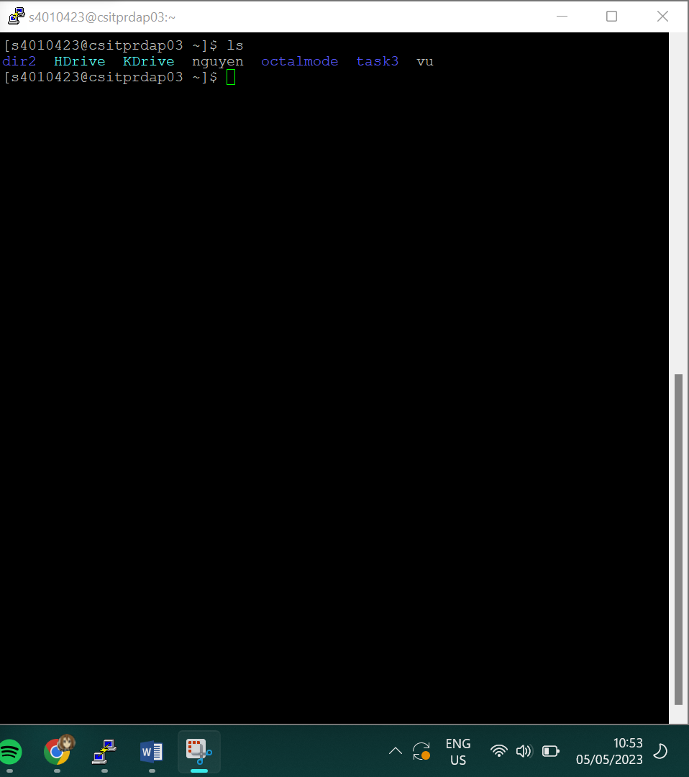

Task 2 – File Permissions (3x1 = 3 points)

Question | Answer
1. | User:read,write  Group:read  Other:read
2. | no
3. | Chmod 761 fileperms

Task 3 - Wildcards (6x1 = 6 points)

Question | Answer
1. | Screenshot  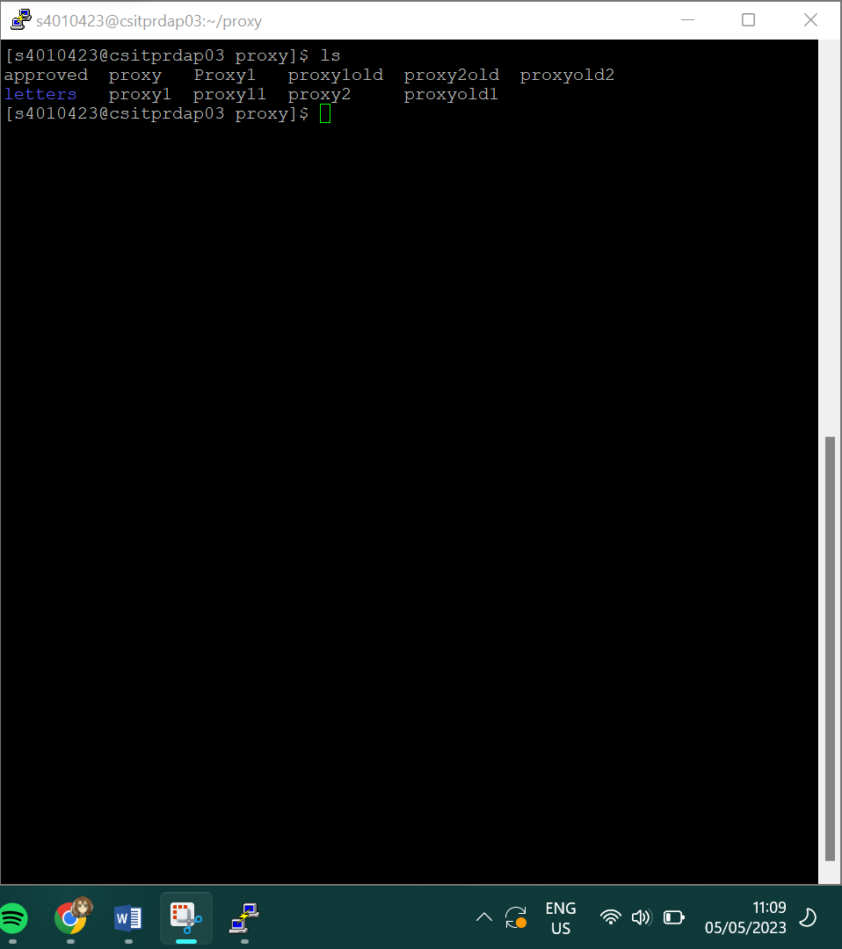
2. | proxy11 and proxy1old
3. | Proxy1 and Proxy1
4. | Cp *{d,2} letters
5. | Mv *pro* letters
6. | Cd ??????

Task 4A – Short Answer Questions (1+2+2 = 5 points)

Question | Answer
1. | Fri May 5 11:18:11 AEST 2023  This is the last line of the file
2. | Permission denied, I do not have permission to change the file as the chmod has not allowed me to
3. | I can only write on the johnsfile file. Reason being that the chmod is configured that both the group and the owner of the file of the group can read and write only while other can only read

Task 4B – TRUE/FALSE Questions (10x0.5 = 5 points)
Highlight the correct answer (T or F).

1. T/F
2. T/F
3. T/F
4. T/F
5. T/F
6. T/F
7. T/F
8. T/F
9. T/F
10. T/F

- Submit your answer sheet (name it yourstudentID_Lab2) to Canvas (Assignments → Lab Exercise 2).
Note: Before you submit your answer sheet, show your work to your teacher (the output of history command).
➢ Close the PuTTY session.

